**IFT 166 Introduction to Internet Networking**

**Lab 11**

**Spot the difference**

**After you complete each step, put a ‘√’ or ‘x’ in the completed box   
or**

**Provide answers to the 4 open questions**

**Objective**

By comparing the configurations in two topologies, find the configuration errors in Topology B.

1. In packet tracer, open the file “Spot the difference I” (located in the modules sections below this lab).   
     
   You should see the following 2 topologies.

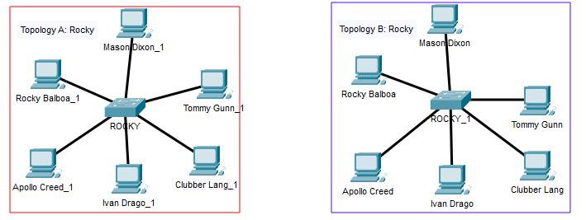



1. All PCs can ping each other in Topology A.

All the PCs in Topology B should be able to ping each other. This is the not the case.  
  
There are 4 configuration differences in the 2 topologies (the 4 incorrect configurations are on Topology B)

**Spot the 4 differences.**

1. List each difference and why it needs to be corrected to allow the communications.



_________________________________________________________________________

_________________________________________________________________________



_________________________________________________________________________

_________________________________________________________________________



_____________________________________________________________________

_________________________________________________________________________



_________________________________________________________________________

________________________________________________________________________